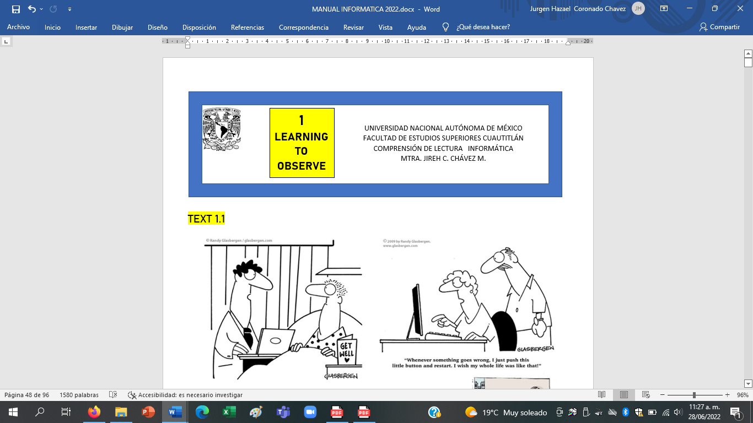

7

**MODAL VERBS**

TEXT 7.1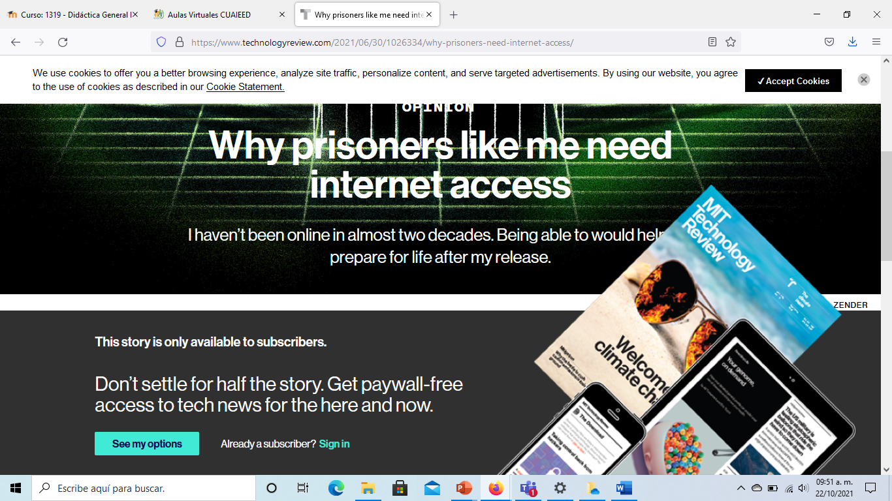

California recently promised to provide free computer tablets to all state prisoners by the end of 2021, allowing prisoners like me to email our loved ones through a highly restricted prison messaging service and download content like movies and books. It’s a great first step, but without more open and frequent internet access, there’s no way we’ll ever truly keep pace with the changing world outside our prison walls.

I’ve been locked up since 2003. Back then Apple had barely launched iTunes, and I was still in awe of the so-called high-speed connection I’d paid Time Warner to install in my apartment. In all the years since then, I haven’t logged a single second of internet activity. My frames of reference for what it means to be online now come from network television and print media.

When my first parole opportunity arrives, in 2023, I’ll be 53 years old. As a convicted murderer, I will need to convince the parole board not only that I have been rehabilitated, but also that I am able to be a productive and employable citizen. It can be hard to keep up with changes in technology even when you’re experiencing them firsthand. When you’re locked away, it’s virtually impossible.

TEXT 7.2

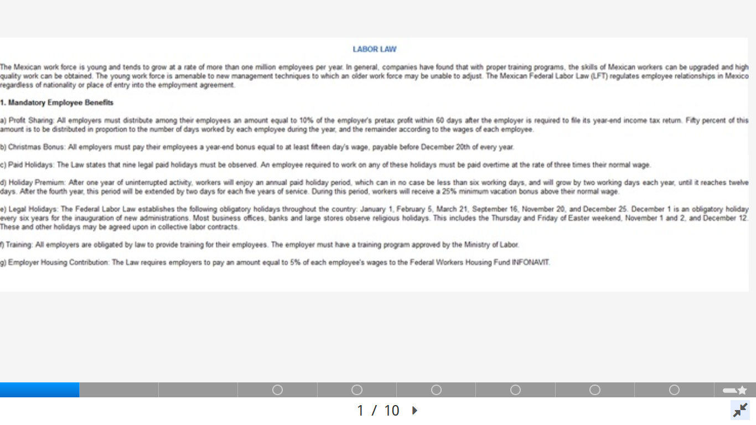

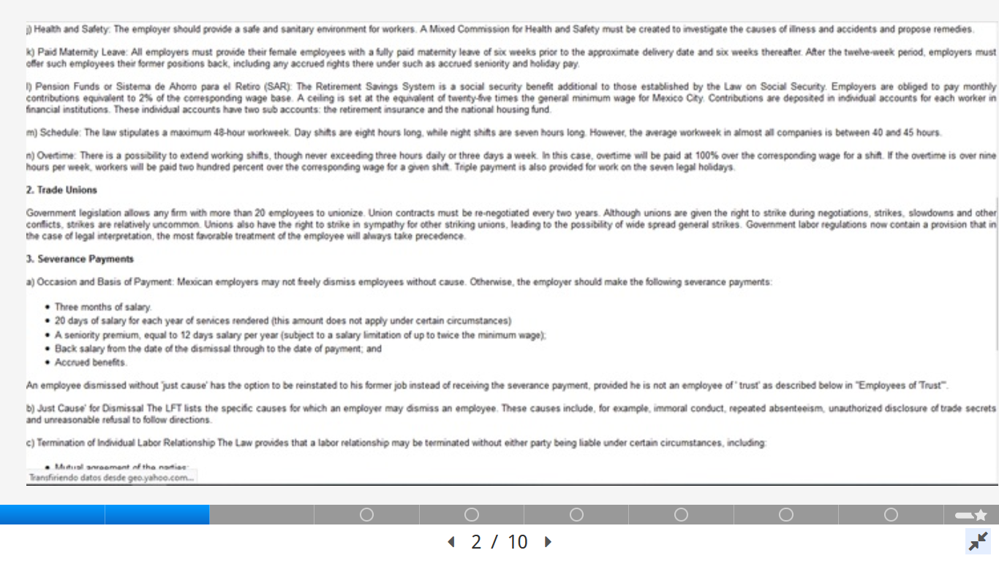

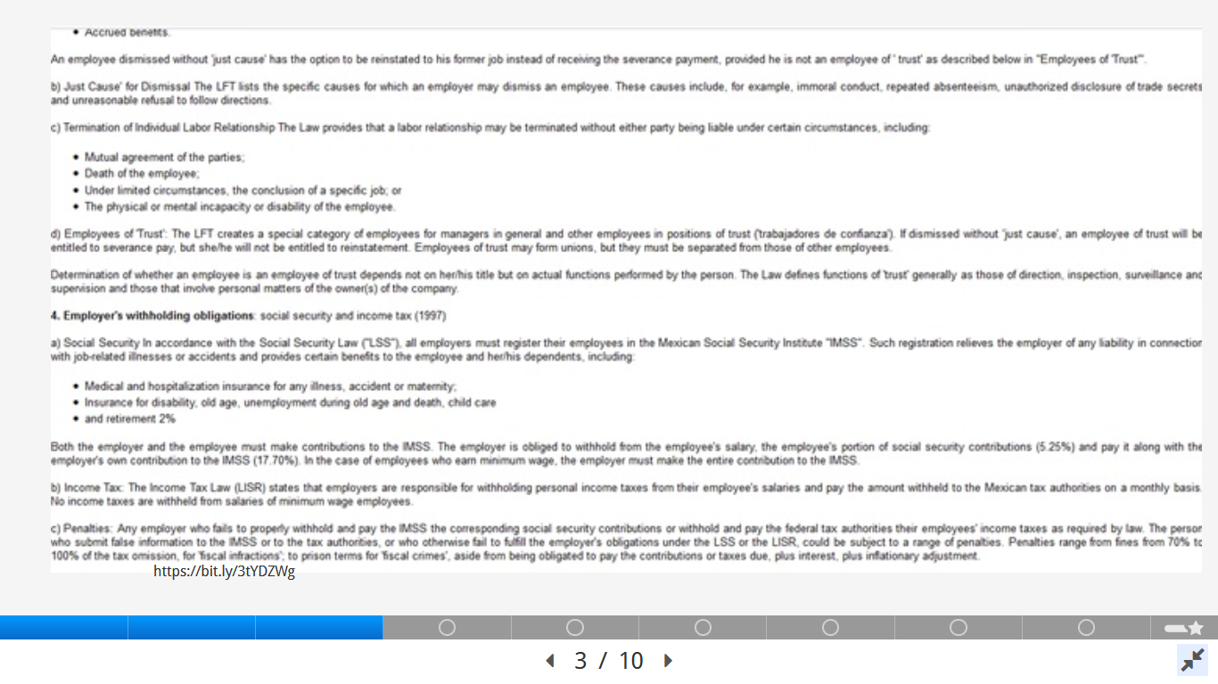

TEXT 7.3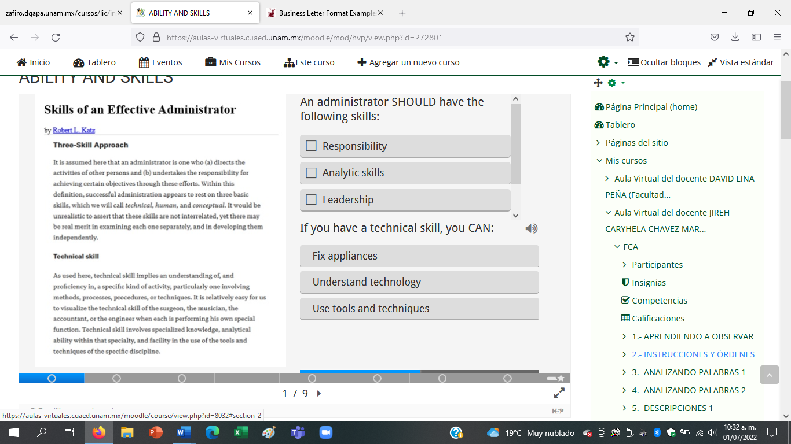

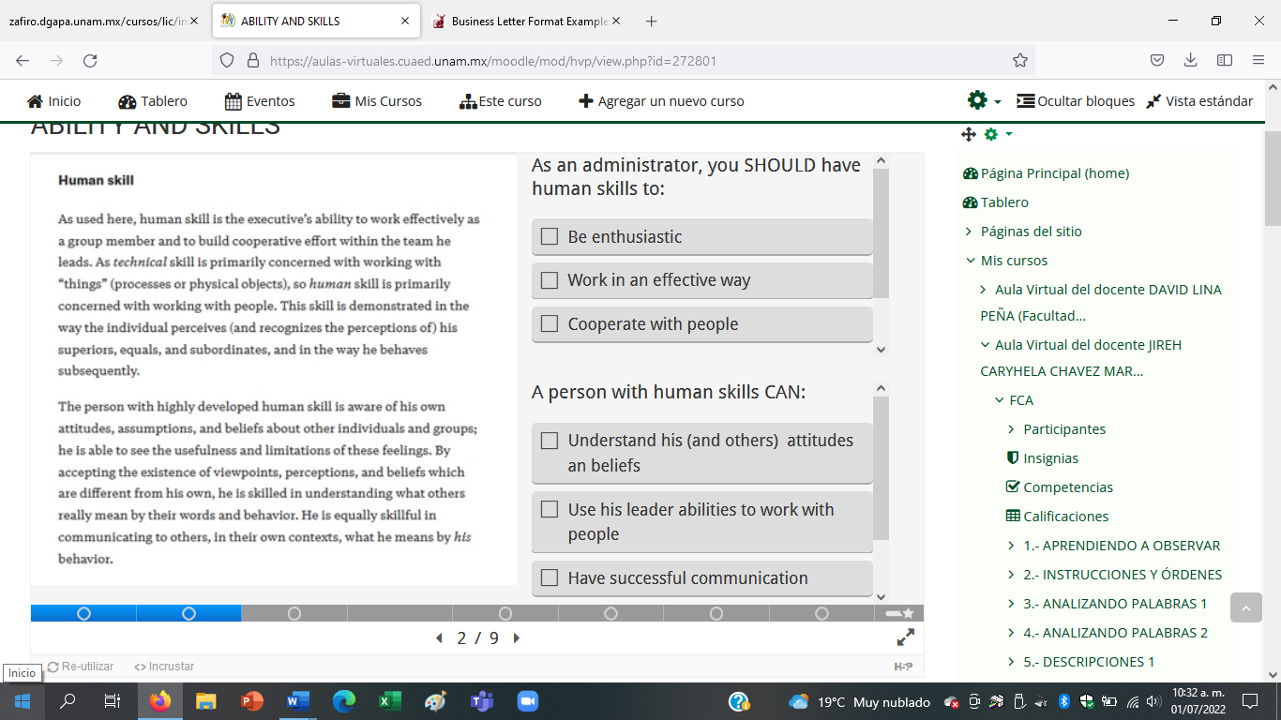

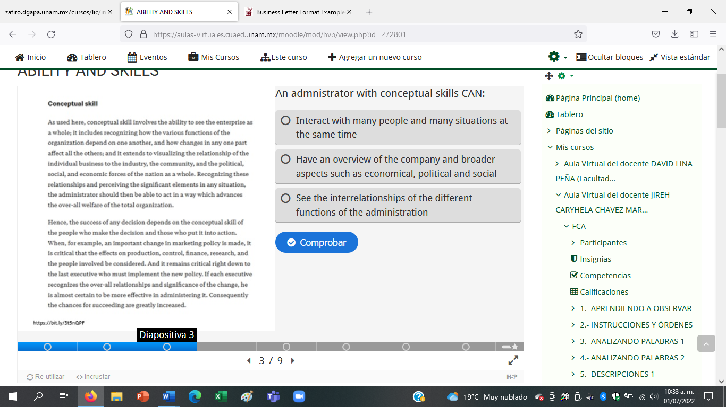

**7.4** 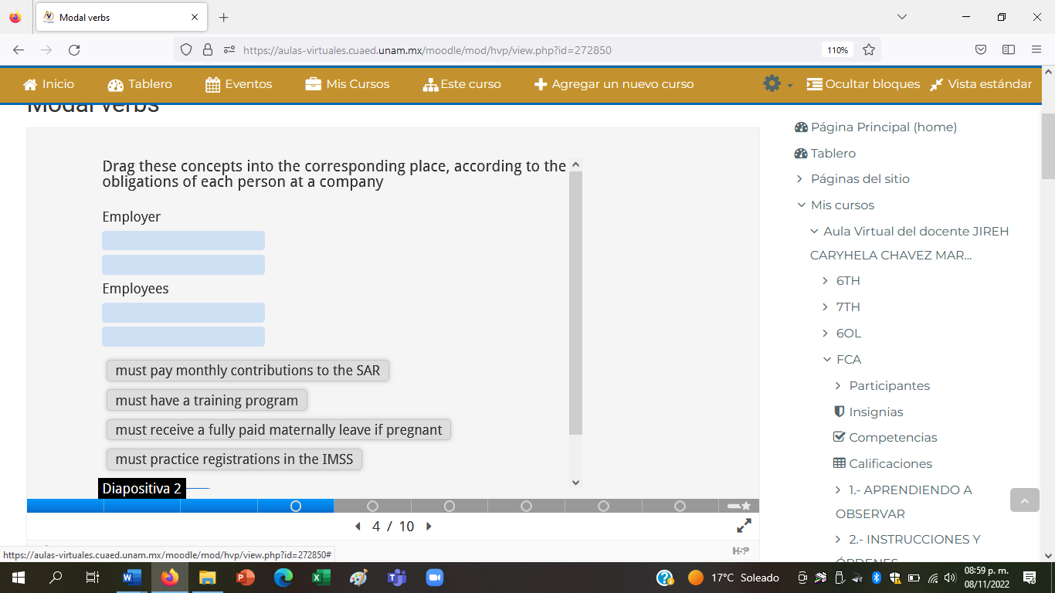

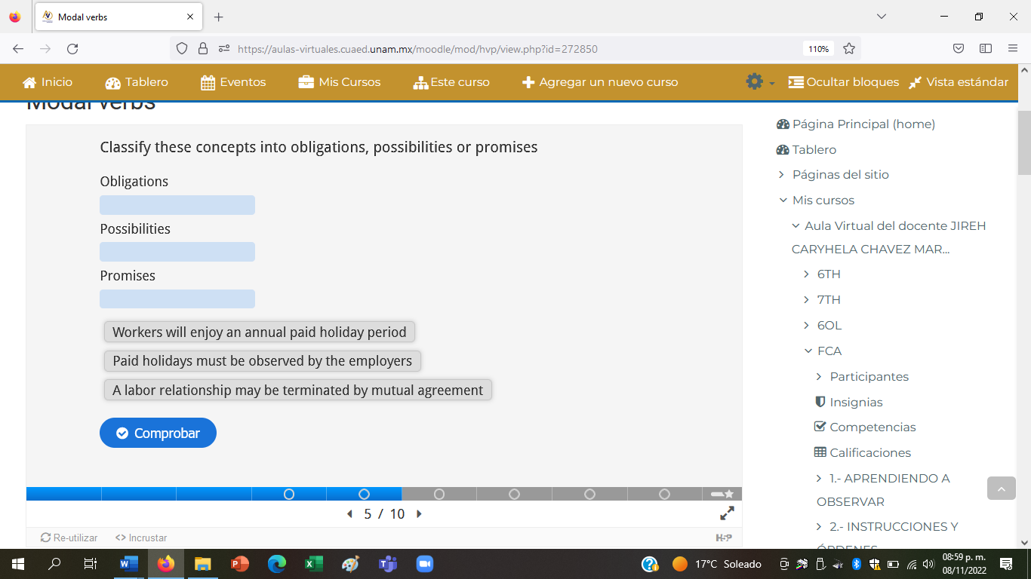

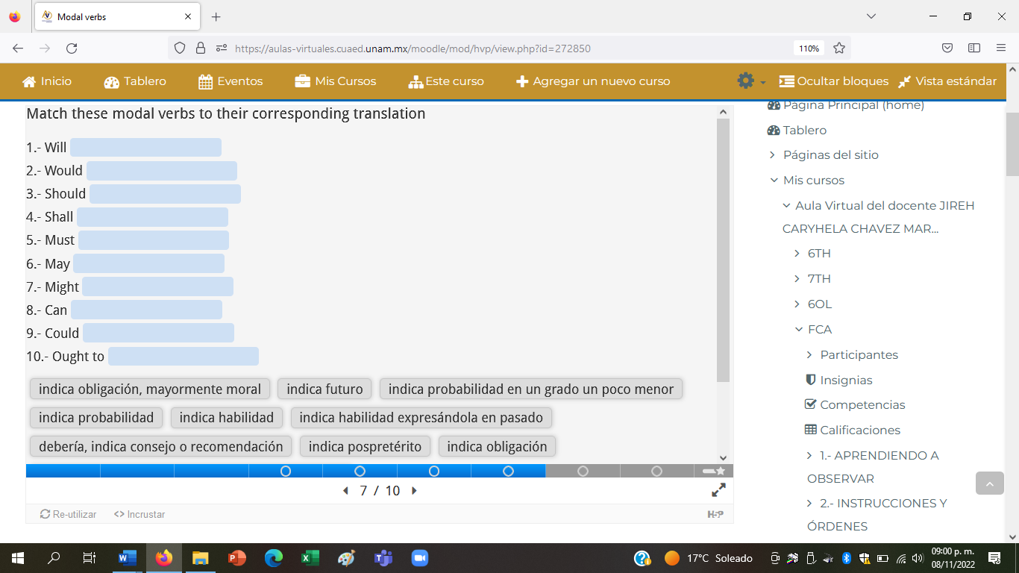

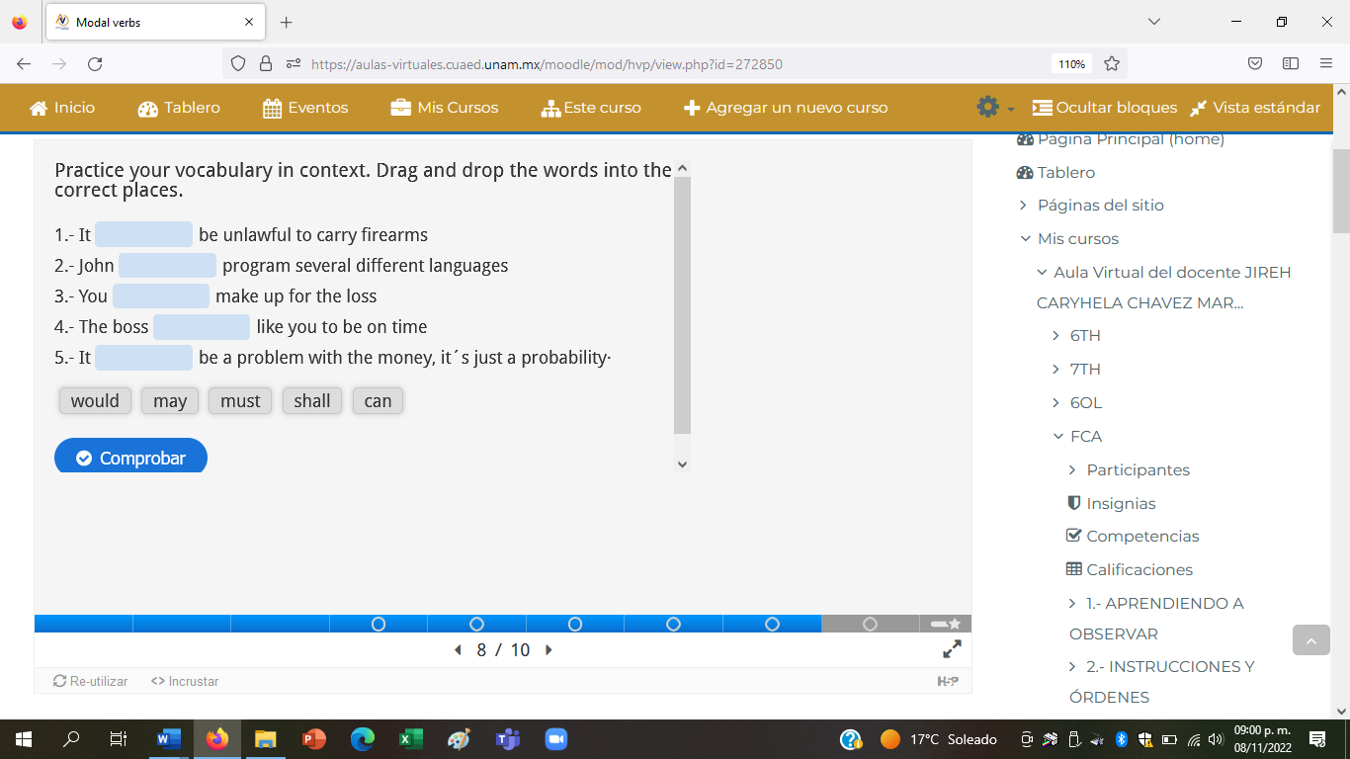

**7.5** 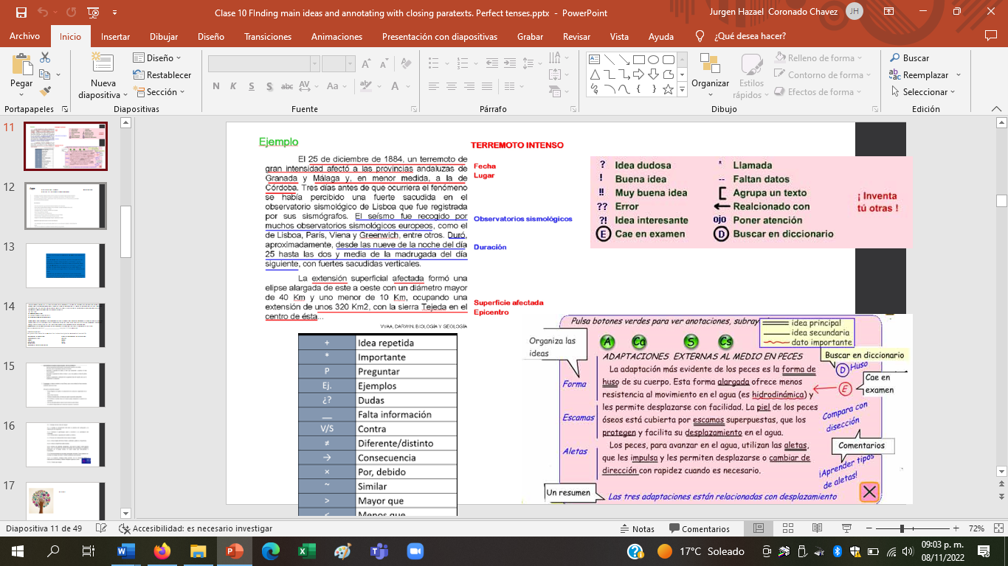

**EXTENSIVE READING: COMPUTER ARCHITECT**



2012

857 pp

Quantitative design

Hierarchy design

Intruction-level pralellism

Thread level paralellism

Instruction set principles

pipelining

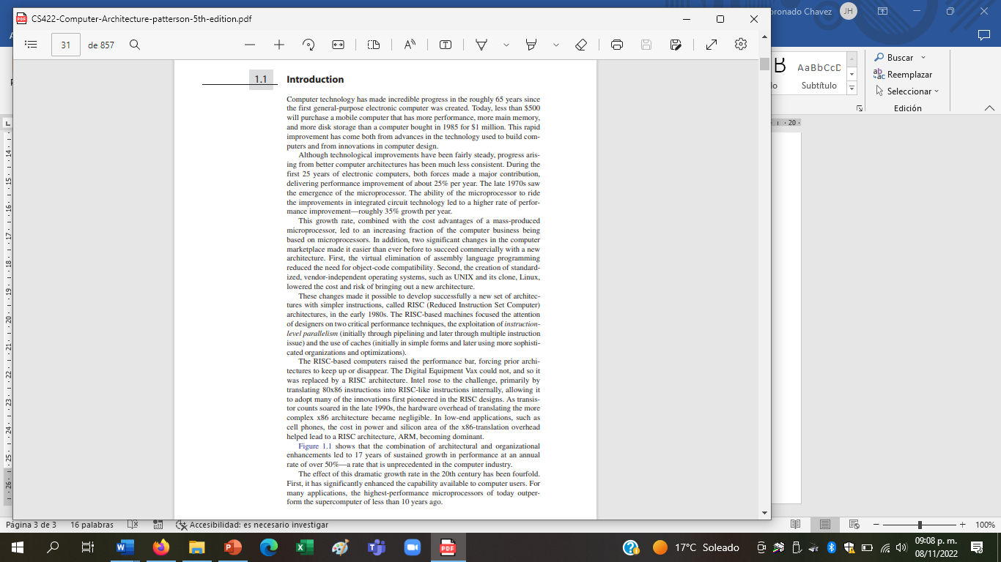

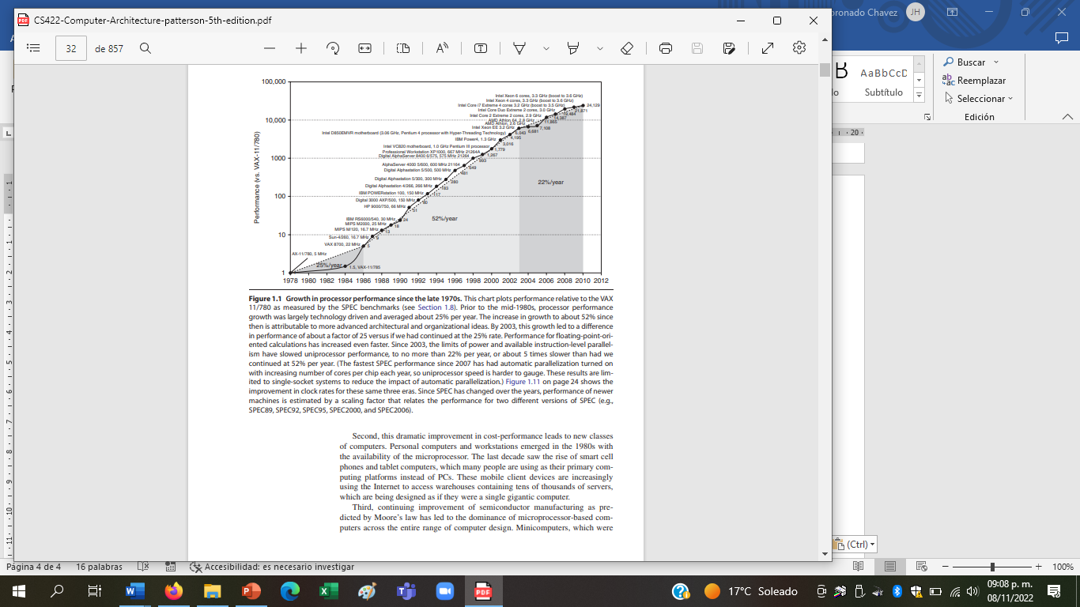

Performance

Enhancement

Advantage

Improvement

Although

Growth rate

pipeline